
Wiltshire Community Web Online Newsletter

December 2009

Hello all and welcome to the latest issue of the Wiltshire Community Web (WCW) Online Newsletter. WCW now contains over 1200 websites from a range of groups and community organisations, including village halls, gardening clubs, parish councils and sports clubs.

Please browse the site (www.wiltshirecommunityweb.org.uk ) for information and ideas for your own website!

Hints and Tips

Online Tutorial – Don’t forget there are 10 lessons that form the WCW Tutorial designed to help you make the most of your WCW website. A link to this can be found on the homepage.

- Creating your homepage | - Adding new pages
- Adding news and diary items | - Advertising a job
- Advanced formatting | - Setting up a mailing list

Each lesson provides simple instructions for you to follow to help you build your site.

News and Diary Modules
Do you have news or events for your local area that you want to share?
Maybe you’re holding an event that is open to the public?

Now that you are a registered user of WCW, why not make use of the News and Diary facilities of your local site. Adding and managing news and diary items can be done easily through your admin page (as shown below).

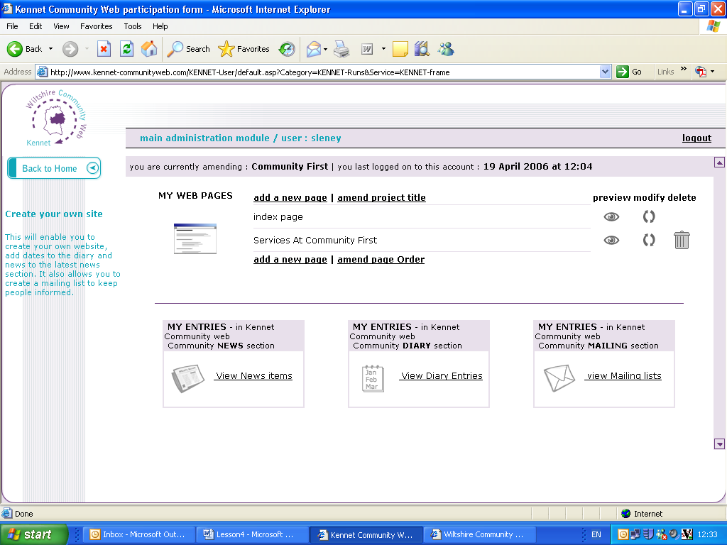
Admin Page
For more information, take a look at Lesson 5 and 6 of the WCW Tutorial.

Promoting your site
Created a fantastic site and want to promote it more?

Then take a look at these tips for promotion and search engine recognition:

- Add your website address to your email signature
- Make sure all your members / colleagues etc know how to find your website and the address
- Add your web address to minutes / posters / leaflets etc
- Add a news item to your local area of WCW to let people know you have a site set up and when new pages and items are added
- Purchase your own domain name and re-direct it to your WCW site
- Get your site featured in the ‘Spotlight’ section of this newsletter
- Always complete the keywords and description boxes at the end of each page template – but keep these to a selective minimum
- Ensure your page content mentions these keywords
- If possible, use these keywords as part of your page title
- Ask external websites to add a link to your site - e.g. your parent organisation and other local sites
- Keep your website fresh and up to date – new content ensures that search engines pick it up quicker

If you have any tips or imaginative ideas on promotion – share it with us all!
Email info@wiltshirecommunityweb.org.uk

Spotlight on a Wiltshire Community Web Site
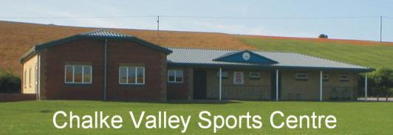

In May 2003 the Chalke Valley Sports Centre was opened, and in a meeting soon after that, it was decided to have a web site. After looking at different possibilities, it was decided to use the South Wilts Community Web Site. (Now the South Wiltshire area of Wiltshire Community Web).

Later in 2003 I set up a site for the Chalke Valley Sports Centre, with a page for each of the Sports Clubs using the Sports Centre, it was soon clear that each club needed more than one page after I received the information that the clubs wished to be published on the internet.

Various pages were set up for each club depending on the information to be published. These included an information page, a contacts page, a fixtures page, a results page, a membership form page, and a history page. Luckily not all the clubs required one of each. To advertise the web site we printed the web address on our correspondence, and advertised in the local village magazines, of Bishopstone, Bowerchalke, Broad Chalke, and Ebbesbourne Wake.

Although the Sports Centre is in Broad Chalke, it is funded by the Parish Councils of Alvediston, and the above villages. The original project was fronted by a committee, which included people from the West End of the Chalke Valley, interested in sport. This committee with the financial backing of the above Parish Councils, Sport England, the football clubs, cricket clubs, tennis club, and table tennis club, managed to raise over £550,000.00 to have the Sports Centre built.

The Wiltshire Community Web Tutorials were marvellously simple and a great help in learning the early tips and tricks. There are usually some extra tips on each issue of the Wiltshire Community Web Newsletter which we found helpful.

Since its inception, the Chalke Valley Sports Centre web site has been updated at least once a month with the current month’s bookings. We have also used the diary area to advertise our annual fete, and have had cause to use the Mail Listings. Our web site does not have so many pages for each club now, as the Cricket and Football Clubs have their own web sites, but we still maintain a page for both of these two clubs, as a link to their own web sites.

The web site has been useful to the sports clubs as we have received many members who found out about us via the internet. I still have history pages to complete, and so the site is being amended on a regular basis.

Malcolm Penney

Visit the site on Wiltshire Community Web:
www.southwilts.co.uk/site/Chalke-Valley-Sports-Centre/Index.htm

Get your site noticed!

For each newsletter, we feature a site that has been created on Wiltshire Community Web.

If you would like to have your site featured here in a future issue to promote your success, then get in touch!

Email us at info@wiltshirecommunityweb.org.uk with a short explanation of your site.

Spread the word!

Help promote Wiltshire Community Web amongst your local community. Anyone can use the facility and get a presence on the web.

We want to encourage all groups and organisations to set up a site, from the local gardening club to the village shop.

Leaflets are available if you would like to display these in your area, please contact Sharon Leney on 01380 722475 or email info@wiltshirecommunityweb.org.uk

Editors Notes

Wiltshire Community Web is managed by Community First.

Community First is a charitable organisation that works at the forefront of community development to help improve the quality of life and economic well being of people and local communities throughout Wiltshire and Swindon

For further information visit our website at www.communityfirst.org.uk

Community First, Wyndhams, St Josephs Place, Devizes, Wiltshire, SN10 1DD
Tel: 01380 722475 Fax 01380 728476

Registered Charity No: 288117
VAT Registration No: 639 3860 06
Company Limited by Guarantee Reg. No: 1757334 England
Registered with the Financial Services Authority No: FRN 311971

